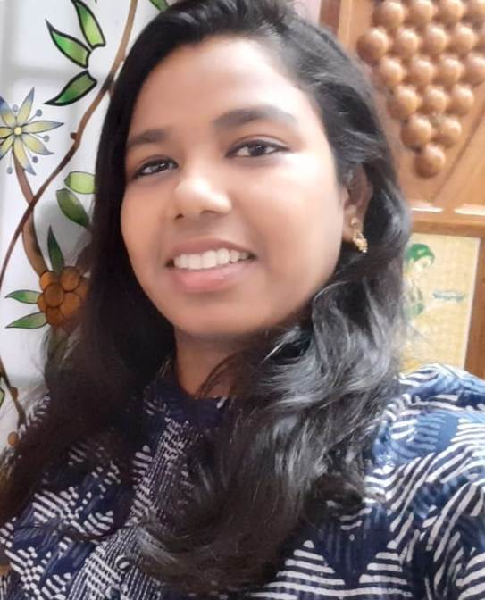

Nirmala Priyadharshini P

B,3rd Main Road,

Krishnaapa Layout,

Kamadhenu Nagar,

B. Narayanapura

Banglore 560077**•**

Ph: 91-9629026814 **•** nimipeter88@gmail.com

|  |  |
| --- | --- |
| ▼ **Objective**  To excel in the field of technical by applying my skills, intellect with conscience, involvement and dedication, ultimately resulting in the development of the organization and the self. | |
| ▼ **Experience and Responsibilities**  •Aug 2011–June 2019  • **Teaching**  • **Assistant Professor**  • **Bharathiyar college of Engineering and technology, Karaikal (Puducherry UT)**   * Performed in-depth research and data collection for use in academic publishing projects. * Communicated with contractors and vendors to place and receive orders, request maintenance services and deliver instruction on behalf of office management. * Provided guidance for student thesis and dissertation work. * Planned class material to engage students in both online and in-person class environments. * Adapted methods of instruction, as well as classroom materials to address student needs. * Collaborated with professors and faculty members in contribution to Projects * Utilized creative instruction methods to promote student learning objectives. * Developed lesson plans to teach course materials according to schedule. * Developed and maintained effective frameworks, standards and requirements. * Managed and controlled office supply inventory to ensure timely ordering or requisition of depleted or low-level stock | |
| ▼ **Area of Interest**   * Networks and Cryptography * DBMS * Software engineering | |
| ▼ **Education** | |
| **Master of Engineering** | |
| * Annamalai University – Chidambaram - **M.E., - 79.4%** * Specialization: Computer Science * Year of Completion : May 2011 Course Duration: 2 Years | |
| **Bachelor of Engineering** | |
| * Periyar Maniammai Institute of Science & Technology – Thanjavur - **B.E.,- 72 %** * University: Anna University-Chennai * Specialization: Information Technology * Year of Completion : April 2009 Course Duration:4 Years | |
| **HSC** | |
| * T.N.Higher.Secondary,School – Poraiyar – **77.3%** * Board of Examination: State Board * Year of Completion : April 2005 | |
| ▼ **Technical Expertise** | |
| * Web Development Tools : Php, Asp,HTML. * Languages : C, C++, Java, Dot Net. * Databases : Oracle 9i, MySql * Operating Systems : Windows, RedHat Linux . * Unified Modeling Tools : Rational Rose | |
| ▼ **Academic Activities** | |
| * Classroom management * Class instruction * Student progress reporting * Student records management * Student counseling | * Academic advisement * Classroom presentations * Lesson planning * Curriculum development * Data collection and analysis |
| ▼ **Academic Projects** | |

|  |  |
| --- | --- |
| **Web Designing For CEDRES Pvt.Ltd** | |
| Operating system | : Windows 2000 or higher |
| Software | : HTML |
| TeamSize | : single |
| Description | : To create website for the private company. It is registered in the network society |
|  | |
| **MultiHoming Using ISP** | |
| Operating system | : Windows 2000 or higher |
| Software | : Java Swing. |
| TeamSize | : 3 |
| Description | : The main objective of this project is to perform automatic process for controlling the congestion in network path. |
|  | |
| **Automatic Gait Recognition System** | |
| Operating system | Windows 2000 or higher |
| Software | MATLAB R2009b |
| TeamSize | Single |
| Description | The main objective of this project is to perform automatic process for identifying the person without human interaction using their walking measurements. |

|  |
| --- |
| ▼ **Personal Details** |
| Husband's Name : Mr.G.Jayaseelan  DOB : 10th June, 1988  Languages known : Tamil,English  Hobbies : su-do-ku solving, trying to know new trends |
| ▼ **Declaration** |
| I hereby declare that the above-mentioned information is correct up to my knowledge and I bear the responsibility for the correctness of the above-mentioned particulars.  Date  : 23.06.2019  Place : Bangalore **[Nirmala Priyadharshini]** |